VULNERABLITY ASSESSMENT AND PENETRATION
TESTING REPORT

Name: F Mohammed Aadham
To: Final Exam
Testing Website: Ehack Team Communication Portal

Reconnaissance:
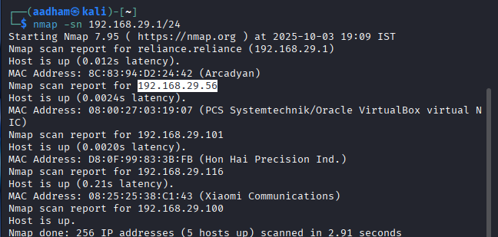

- Using the command to identify (nmap-sn 192.168.29.56)
- Find and confirm that the target IP is 192.168.29.56

Vulnerability:

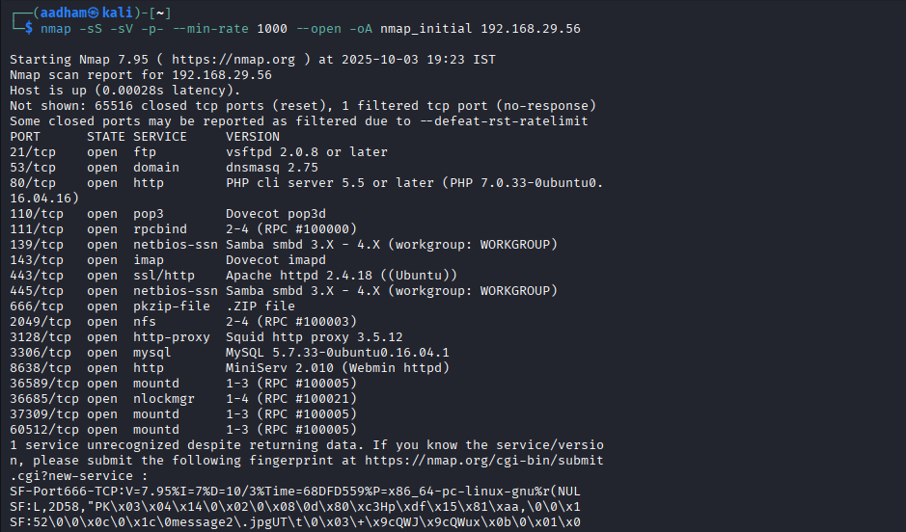
- Outdated Web Server / PHP
Affected: HTTP (80) PHP 7.0.33; HTTPS (443) Apache 2.4.18.
Severity: High
Evidence: Nmap: 80/tcp open http PHP 7.0.33 / 443/tcp open ssl/http Apache 2.4.18.
Impact: Known RCE/info-disclosure vulnerabilities risk full app/host compromise.
Remediation: 1) Upgrade OS/PHP/Apache to supported versions. 2) Remove PHP CLI in production; use PHP-FPM. 3) Harden Apache (disable unused modules, enable mod_security).

- Exposed Webmin Management Interface
Affected: Webmin MiniServ on 8638/tcp.
Severity: High
Evidence: Nmap: 8638/tcp open http MiniServ 2.010 (Webmin).
Impact: Unrestricted access may allow remote admin takeover.
Remediation: 1) Restrict access via firewall/VPN to admin IPs. 2) Update Webmin and enable MFA. 3) Uninstall/disable if not required.

- Exposed File & DB Services (Samba, NFS, MySQL, FTP)
Affected: Samba 139/445, NFS 2049, MySQL 3306, vsftpd 21.
Severity: High/Medium
Evidence: Nmap shows Samba, NFS, MySQL, FTP services open.
Impact: Possible unauthorized file/database access or data leakage.
Remediation: 1) Limit access with firewall/host ACLs. 2) Audit and enforce least-privilege share permissions. 3) Patch services and disable anonymous/FTP where possible.

- Open Proxy & Unexpected ZIP-like Service
Affected: Squid proxy (3128) and unknown service on 666/tcp returning ZIP-like data.
Severity: Medium
Evidence: 3128/tcp open http-proxy Squid 3.5.12; 666/tcp responds with PKZIP signature.
Impact: Proxy abuse and accidental exposure of archived/backups.
Remediation: 1) Restrict/require auth for Squid; update it. 2) Investigate 666 process and remove/move exposed archives. 3) Monitor and block unauthorized proxy usage.

FFUF Directory Enumeration:

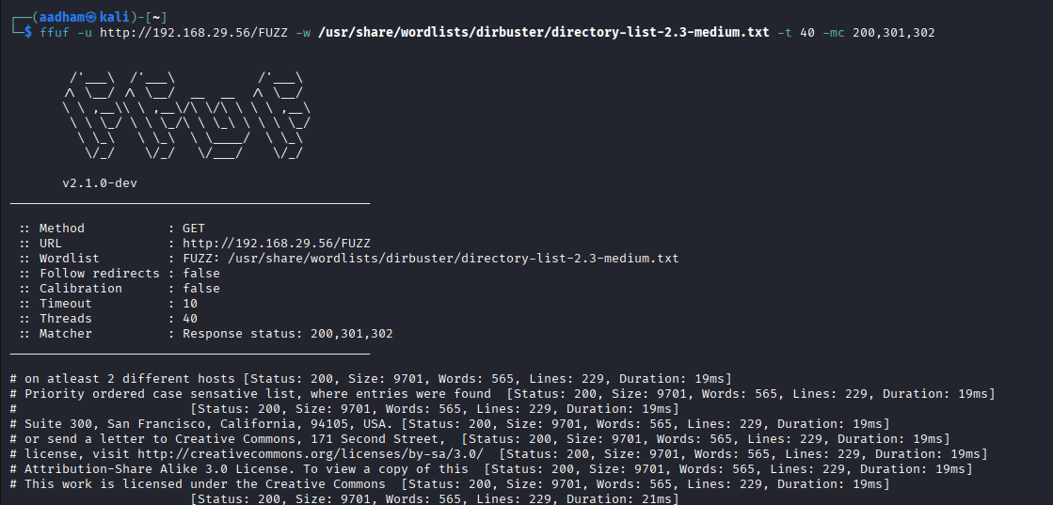

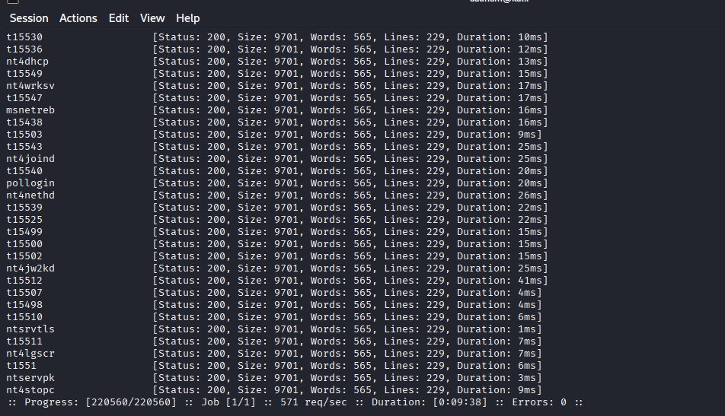
Title: Directory / File Enumeration — Response content discovered by FFUF
Tool / Command: ffuf -u http://192.168.29.56/FUZZ -w /usr/share/wordlists/dirbuster/directory-list-2.3-medium.txt -t 40 -mc 200,301,302 (ffuf v2.1.0-dev)
Timestamp: 2025-10-03 19:23 IST (local test time)
Finding: FFUF discovered directories/endpoints returning HTTP 200 with identical response bodies (size: 9701 bytes). The returned content includes Creative Commons license text and what appears to be generic site content — indicates one or more accessible directories that serve the same index page or a default page.
Evidence: FFUF output lines showing Status: 200, Size: 9701, Words: 565, Lines: 229 and sample response snippets:
- “Suite 300, San Francisco, California, 94105, USA.”
- “This work is licensed under the Creative Commons…”
(Full FFUF output saved as ffuf_dirs.json — appended to appendix.)
Reproduction steps:
- Run FFUF with the provided command against http://192.168.29.56/.
- Review results for responses with status 200 or redirects 301/302.
- For each discovered path, request the URL in a browser or via curl -I -L and capture headers and body.
Impact: Information disclosure / enumeration. An attacker can map accessible endpoints, identify default pages/backups or undeclared content and use this to further target the application (e.g., find admin panels, backup files, or outdated pages). On its own this is usually Low–Medium severity depending on what files are discovered. In this run the content appears generic (Creative Commons/license), suggesting low immediate sensitivity but confirming that directory enumeration is successful.
Recommendation (3 steps):
- Remove or secure any unnecessary or default files and directories from the webroot (archives, .bak, test pages).
- Implement strict directory listing and indexing controls (disable directory index, return 403/404 for non-existing paths).
- Place sensitive or backup files outside the webroot and restrict access via authentication/firewall rules.
Suggested severity (estimate): Low (informational) — escalate to Medium if sensitive backups or admin pages are discovered.
Attachments: ffuf_dirs.json, screenshots of discovered pages, curl response headers for representative URLs, and timestamped ffuf console log.

OWASP TOP 10:
Broken Access Control:

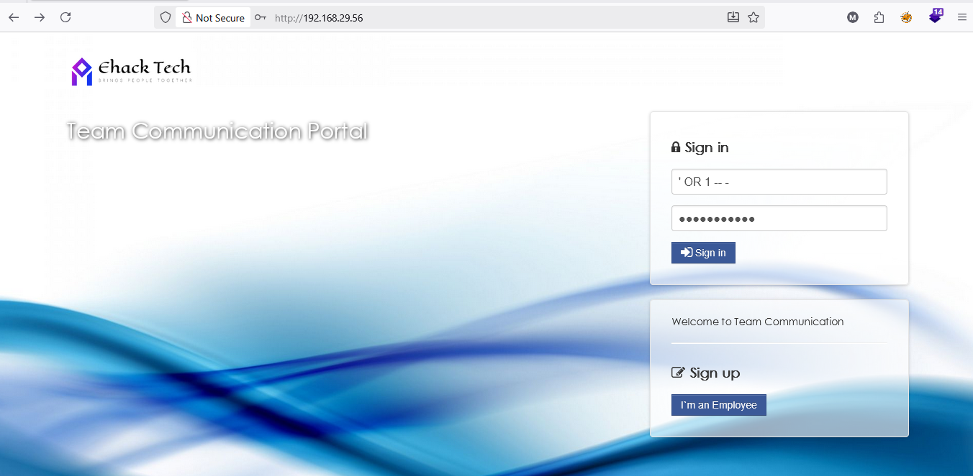

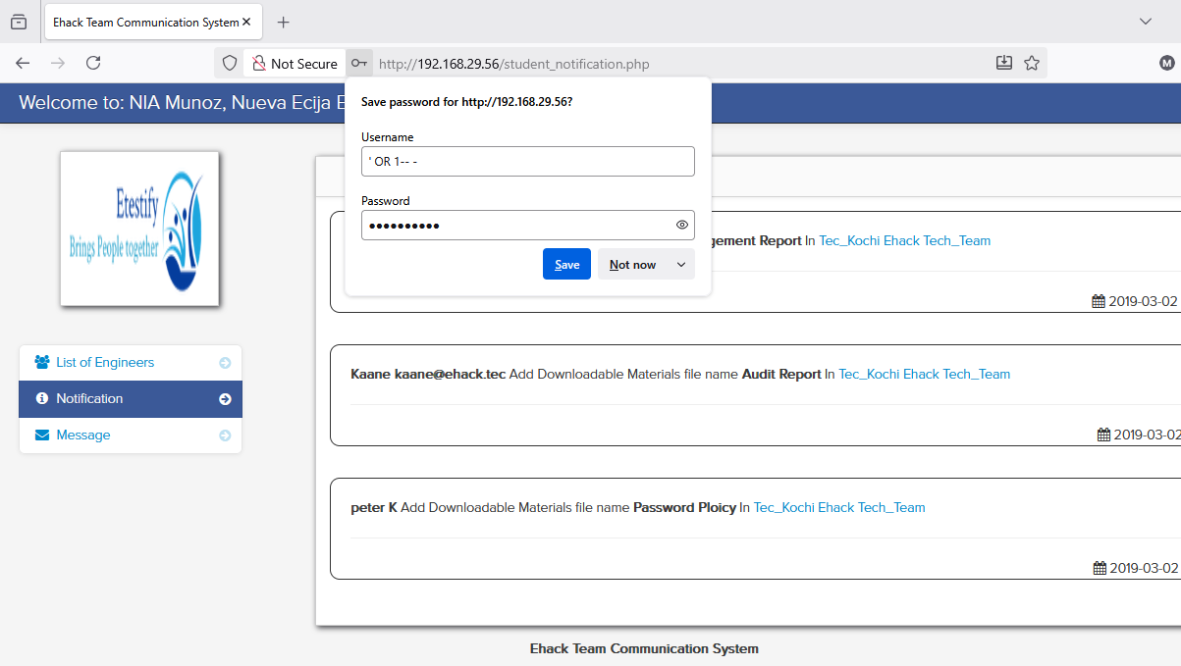

- Vulnerability Type: The application fails to enforce proper access controls on the login and protected endpoints, allowing attackers to access or perform actions beyond their assigned privileges (e.g., missing authorization checks, insecure direct object references, or flawed session/role handling). Attackers may manipulate input or parameters (for example, using payloads such as ' OR 1--) to bypass checks or access resources they shouldn’t.
- Impact: Exploitation enables attackers to view, modify, or act on resources they should not be allowed to access — such as other users’ accounts, administrative functions, or sensitive application data — leading to confidentiality and integrity breaches.
- Risk: A successful attack can result in full account takeover, unauthorized data disclosure, tampering with team communications or records, and lateral privilege escalation, potentially compromising critical systems and stored credentials.

SEVERITY | SCORE | MITIGATION
HIGH | 8.6 | - Enforce Server-Side Authorization: Implement strict role-based or attribute-based access controls on every sensitive request to ensure users can only access authorized resources.  - Validate Object Ownership: Always verify user permissions before granting access to specific data or actions, preventing unauthorized access or privilege escalation.  - Secure Session Management: Use unique session tokens, ensure proper session invalidation after logout, and regularly audit access control logic to identify potential weaknesses.

Security Misconfiguration:

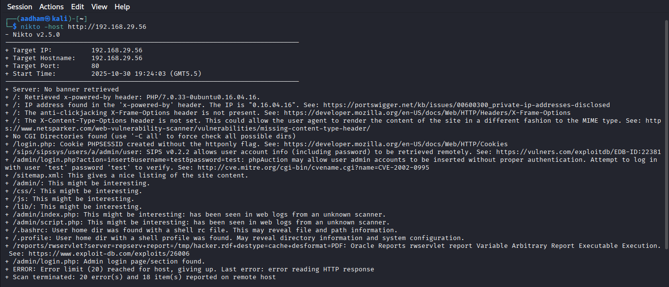
- The HTTP response discloses X-Powered-By: PHP/7.0.33 — PHP 7.0 is EOL and has known, unpatched vulnerabilities.
Version disclosure simplifies attacker reconnaissance and targeted exploitation.
Upgrade PHP to a supported release and remove version banners to reduce targeted risk.
- Responses lack key HTTP security headers (e.g., X-Frame-Options, X-Content-Type-Options, Content-Security-Policy).
This leaves users vulnerable to clickjacking, MIME sniffing, and some XSS-related issues.
Add recommended headers at the webserver level to mitigate a broad class of client-side attacks.
- Nikto reported the session cookie (PHPSESSID) is created without HttpOnly. JavaScript can read such cookies.
If XSS exists, attackers can steal the session cookie and hijack accounts.
Set HttpOnly (and SameSite/Secure) for all session cookies to mitigate cookie theft.

SEVERITY | SCORE | MITIGATION
MEDIUM | 6 | - Upgrade PHP to a supported version and disable version disclosure.  This reduces risk from known PHP vulnerabilities.  - Configure the webserver to include security headers like X-Frame-Options and Content-Security-Policy.  This helps prevent clickjacking, XSS, and MIME-type attacks.  - Enable HttpOnly, Secure, and SameSite attributes for session cookies.  This protects against session hijacking and cookie theft.

SQL Injection:
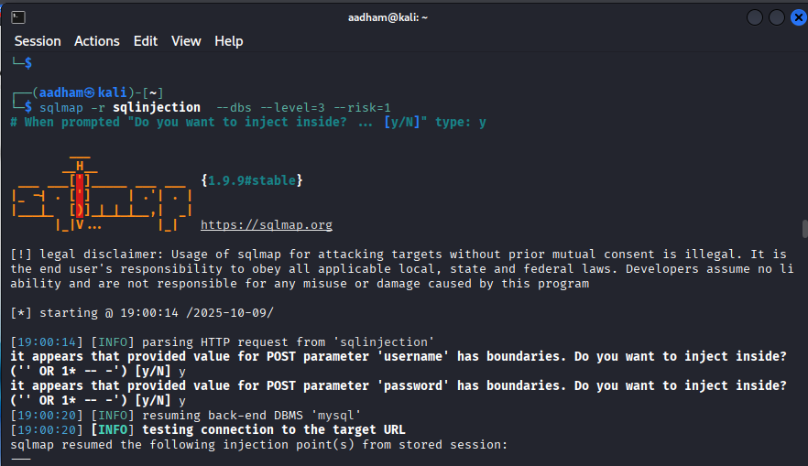
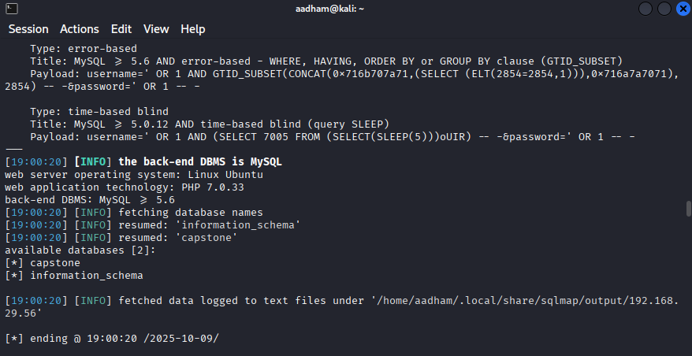

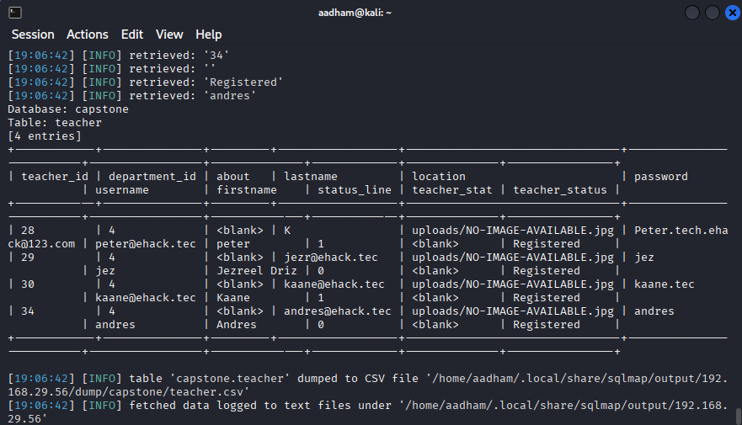

- Confirmed SQL injection vectors.
sqlmap found boolean-based, error-based and time-based payloads for the username POST parameter.
This proves input is injectable and can alter query logic or behavior.
- Server and DB fingerprinting.
Tool identified MySQL (>=5.6), PHP 7.0.33 running on Ubuntu.
Those fingerprints let an attacker choose payloads and exploitation techniques that fit the stack.
- Immediate data exposure risk.
sqlmap listed databases capstone and information_schema, showing enumeration succeeded.
An attacker can enumerate tables and potentially extract schema or confidential rows.

SEVERITY | SCORE | MITIGATION
HIGH | 8.8 | - Use parameterized queries or prepared statements to ensure user input is never directly concatenated into SQL queries, effectively preventing injection attacks.  - Implement strict input validation and sanitization by allowing only expected characters and formats, and suppress detailed database error messages from being shown to users.  - Apply least-privilege principles by using restricted database accounts, disabling unnecessary DB functions, and enabling logging or WAF monitoring to detect and block malicious activities.

Cryptographic Failure:
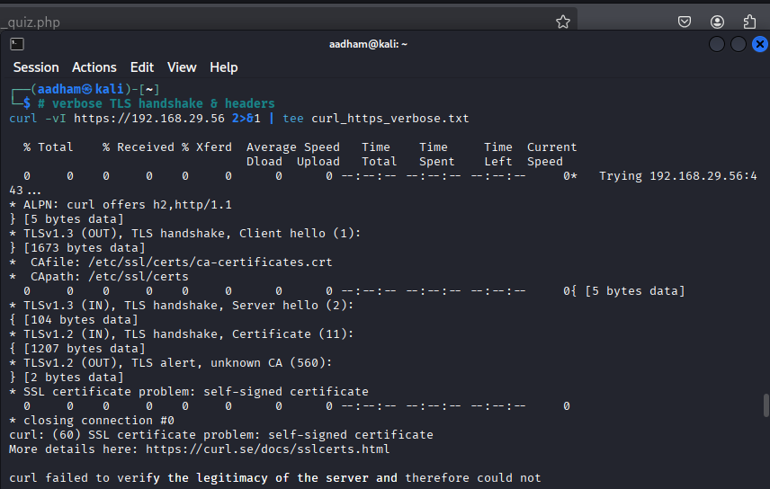

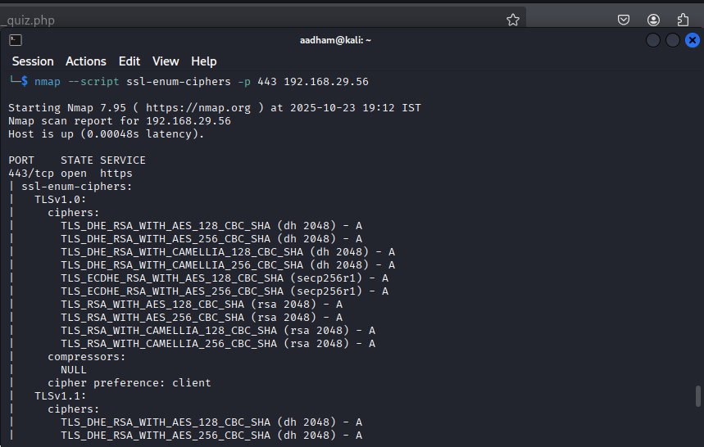

- nmap --script ssl-enum-ciphers -p 443 192.168.29.56
The server supports outdated TLS 1.0 and 1.1 protocols, which are vulnerable to attacks like POODLE and BEAST.
These older protocols lack modern cryptographic protections and can be exploited to decrypt or manipulate traffic.
Continuing to allow them puts user data at risk and does not comply with current security best practices.
- curl -vI https://192.168.29.56
The HTTPS connection uses a self-signed certificate, preventing clients from verifying the server’s authenticity and allowing potential man-in-the-middle (MITM) attacks.
Clients and browsers will show warnings or fail to connect securely, reducing trust in the application.
In production, this can allow attackers to intercept sensitive information like credentials or session tokens.
- curl -I 192.168.29.56
The HTTP response reveals server software (PHP/7.0.33 on Ubuntu 16.04) in the X-Powered-By header, exposing version information that could be exploited by attackers.
Knowing the exact versions helps attackers target known vulnerabilities specific to that software.
This information disclosure increases the likelihood of automated attacks and reduces overall system security.

SEVERITY | SCORE | MITIGATION
7.2 | HIGH | - Disable weak TLS versions and enable only TLS 1.2 and TLS 1.3 to prevent attacks that exploit outdated protocols (like POODLE and BEAST).  - Use strong ciphers with forward secrecy, such as AES-GCM or ChaCha20-Poly1305 with ECDHE, and configure the server to prefer its own cipher order.  - Replace the self-signed certificate with a trusted CA-signed certificate and ensure the full certificate chain is properly configured so clients can validate it; optionally enable OCSP stapling for better revocation handling.

Vulnerable and Outdated Component:
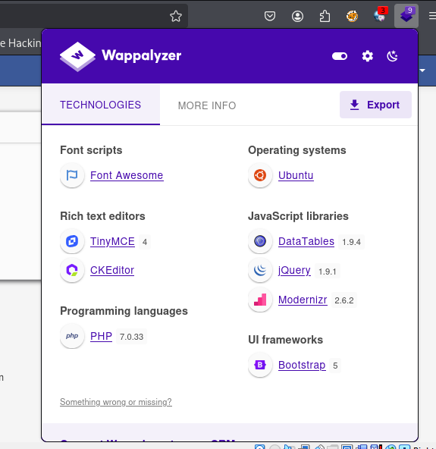
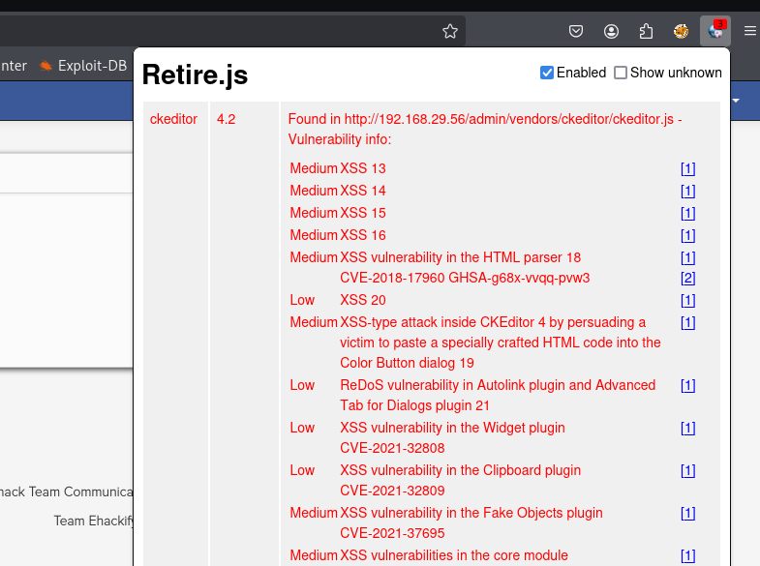

  - Go to the web page.
  - Add the extension like wappalyzer and retire.js. Wappalyzer- used to find the frameworks used to create the website. Retire.js- shows the any outdated components are used in the website and what type of attacks are possible.
  - The outdated componets in the website according to the wapplyzer are:
1) Apache HTTP Server 2.4.18
2) PHP 7.0.33
3) jQuery 1.11.1
4) DataTables 1.9.4
5) Bootstrap 4.0.0-beta
6) TinyMCE 4
7) CKEditor And some of the vulnerable are present in the
retire.js.

SEVERITY | SCORE | MITIGATION
HIGH | 7.5 | • Upgrade EOL Software 🔄: Immediately upgrade all End-of-Life (EOL) components, such as PHP 7.0.33, to a currently supported version to ensure access to security patches.  • Regular Patching 🛡️: Implement a strict, automated policy to regularly apply security patches to all third-party libraries like CKEditor and jQuery to fix known CVEs (vulnerabilities).  • Input Validation & CSP ✍️: Use strict input validation and a Content Security Policy (CSP) to neutralize common attacks like XSS that exploit vulnerabilities in components like the rich text editor.

Insecure Design:
Insecure Design refers to vulnerabilities that arise from a lack of security considerations in the design phase of software development. It encompasses flaws in application architecture, user workflows, and other foundational elements that fail to account for security requirements.
Rate limiting is a technique used by servers and web services to control the number of requests a user or system can make within a specified period. This prevents overloading the server, protects against abuse (like brute-force attacks or DDoS), and ensures fair usage among multiple users.

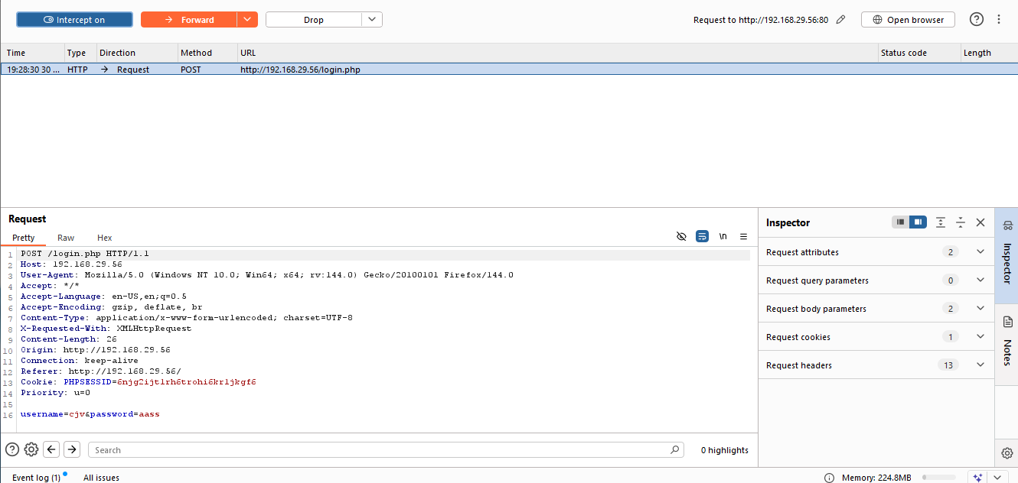

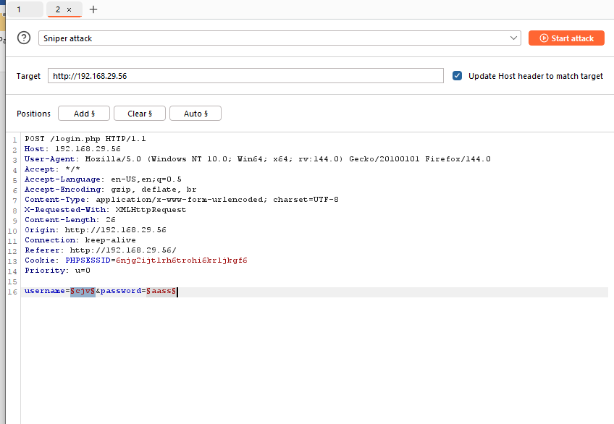

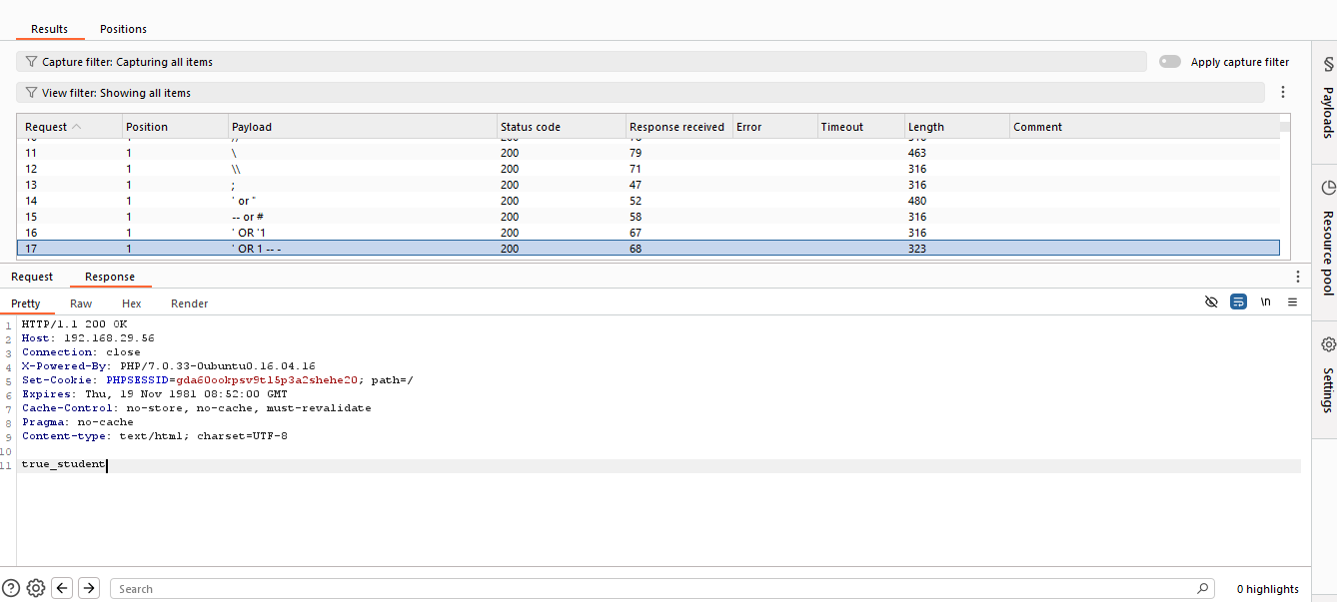

- Evidence of injection probes. Burp Intruder sent classic SQL payloads like ' OR 1 -- to the endpoint. The server returned 200 OK with varying response lengths and the text true_student.
- Behavior indicates input is evaluated by the backend. Different payloads produced different response sizes and content, showing conditional logic. This suggests user input is influencing SQL query outcomes.
- High-impact vulnerability likely present. If confirmed, the flaw can allow authentication bypass or data exposure depending on DB privileges. Further controlled verification is needed to confirm extent and affected parameters.

SEVERITY | SCORE | MITIGATION
HIGH | 8.6 | - Implement Request Rate Limiting:  Configure per-user and per-IP request thresholds (e.g., 100 requests per minute) to block or delay excessive requests automatically.  - Use CAPTCHA and Account Lockout Controls:  Apply CAPTCHA after several failed attempts and temporarily lock accounts or sessions to prevent automated brute-force or abuse.  - Monitor and Alert for Abnormal Traffic:  Deploy logging and monitoring tools to detect unusual spikes or repeated requests, triggering alerts or temporary IP blocking.

Conclusion:
The Vulnerability Assessment and Penetration Testing (VAPT) on the Ehack Team Communication Portal identified several critical and high-severity vulnerabilities that significantly affect the system’s confidentiality, integrity, and availability. The assessment covered reconnaissance, vulnerability scanning, and exploitation testing to evaluate the overall security posture of the application.

Key Findings
- SQL Injection (High Severity – CVSS 8.8)
Confirmed through sqlmap, allowing attackers to manipulate backend queries, access databases, and potentially extract sensitive information.
- Outdated and Vulnerable Components (High Severity – CVSS 7.5)
The system runs on outdated software such as PHP 7.0.33, Apache 2.4.18, and legacy libraries like jQuery 1.11.1 and CKEditor 4, which contain known CVEs and remote exploitation risks.
- Cryptographic Failures (High Severity – CVSS 7.2)
Use of outdated TLS versions (1.0 and 1.1) and a self-signed SSL certificate make encrypted communication vulnerable to interception and man-in-the-middle (MITM) attacks.
- Broken Access Control & Security Misconfiguration (Medium–High Severity – CVSS 6.0–8.6)
Missing authorization checks, version disclosures, and absent security headers (CSP, X-Frame-Options) expose the application to privilege escalation and XSS-related risks.
- Insecure Design – Lack of Rate Limiting (High Severity – CVSS 8.6)
The absence of proper request throttling enables brute-force or denial-of-service attacks, compromising system availability and performance.

Overall Assessment
The application demonstrates multiple security weaknesses across both code-level and configuration-level layers. The exploitation of these vulnerabilities could result in unauthorized data access, account compromise, or full system control. Outdated components and poor access controls indicate a lack of secure development practices and patch management.

Conclusion Summary
- The overall risk level is High, with several exploitable flaws confirmed.
- Immediate remediation is required, focusing on patching, input validation, and enforcing secure design principles.
- The portal should not be used in a production environment until major vulnerabilities are fixed.
- A post-remediation security retest is strongly recommended to ensure vulnerabilities are resolved and the application meets modern security standards.

